Weekly Market Report (May 13, 2011 – May 19, 2011)

MCX – COMDEX

Open: 3397.25 High: 3435.71 Low: 3322.11 Close: 3386.68 Previous close: 3397.73

MCX Comdex was down by 0.33% to 3386.68, MCX Energy was down by 0.92% to 3135.37 and MCX Metal was down by 0.64% to 4390.29.

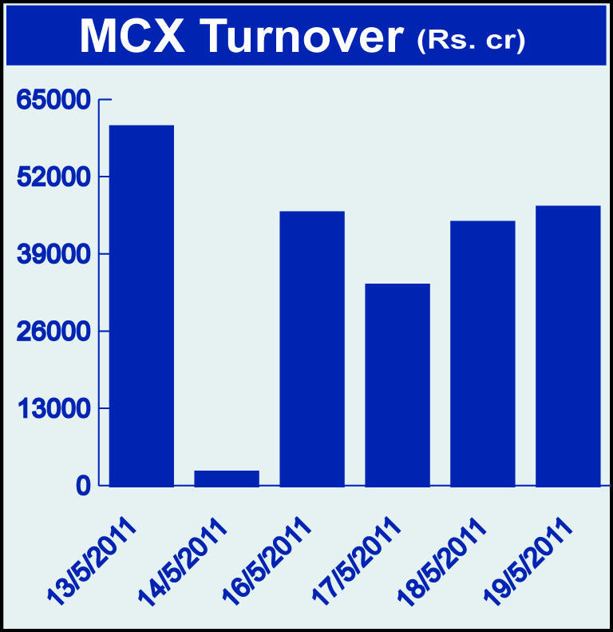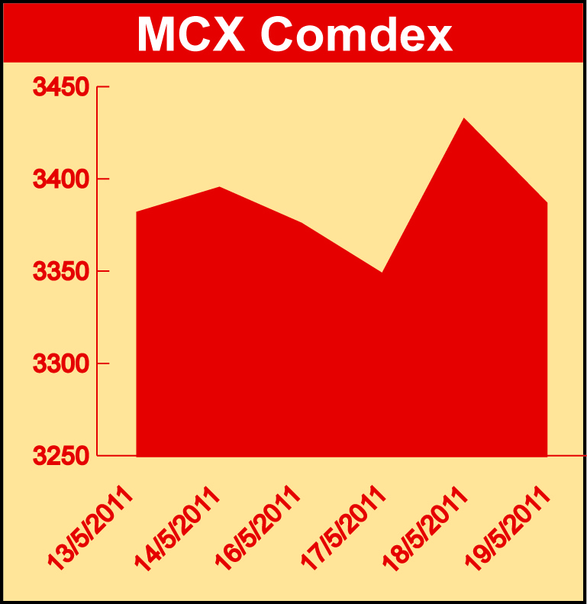

Bullion:
Gold June 11 contract was down by 0.78% to Rs 21884.00 per 10 grams, GoldM July 11 contract was down by 0.94% to Rs 22016.00 per 10 grams and Goldguinea June 11 contract was down by 0.67% to Rs 17738.00 per 8 grams and GoldPetal May 11 contract was down by 0.40% to Rs 2218.00 per grm. Silver July 11 contract was down by 1.64% to Rs 53128.00 per kg, SilverM June 11 contract was down by 1.63% to Rs 53145.00 per kg, SilverMIC June 11 contract was down by 1.64% to Rs 53174.00 per kg.

Metals
Lead July 11 contract was up by 8.62% to Rs 111.50 per kg, lead mini July 11 contract was up by 6.40% to Rs 111.35 per kg, copper June 11 contract was up by 1.50% to Rs 405.15 per kg while zinc June 11 contract was down by 0.96% to Rs 97.50 per kg, zinc mini June 11 contract was down 0.96% to Rs 97.50 per kg, aluminium May 11 contract was down by 4.87% to Rs 112.20 per kg, alumini May 11 contract was down 4.83% to Rs 112.20 per kg and nickel June 11 contract was down by 4.23% to Rs 1077.00 per kg.

Energy
Natural gas May 11 contract was down by 1.91% to Rs 185.10 per MMBTU and crude oil July 11 contract was down by 1.09% to Rs 4538.00 per barrel.

AGRICULTURE:
CPO July 11 contract was up by 2.99% to Rs 526.70 per 10 kgs, refsoyoil June 11 contract was up by 3.41% to Rs 642.25 per 10 kgs while potatoTRWR July 11 contract was down by 4.46% to Rs 408.90 per 100 kgs, sugar July 11 contract was down 2.85% to Rs 2730.00 per 100 kgs, menthaoil July 11 contract was down by 1.98% to Rs 869.30 per kg, cardamom July 11 contract was down by 1.89% to Rs 930.80 per kg and potato July 11 contract was down by 6.34% to Rs 468.00 per 100 kgs.

For further information please contact:

 | Alok Gupta  Sr. Manager, Corporate Communication, MCX  Phone No.: +91 22 6731 8888  Mobile No.: +91 9930267906  Email: alok.gupta@mcxindia.com

Disclaimer:
Multi Commodity Exchange of India Limited is proposing, subject to market conditions and other considerations, a public offer of equity shares by way of an offer for sale and has filed a Draft Red Herring Prospectus ("DRHP") with the SEBI. The DRHP is available on the websites of SEBI at www.sebi.gov.in and the book running lead managers at www.edelcap.com, http://www.online.citibank.co.in/rhtm/citigroupglobalscreen1.htm and www.morganstanley.com/indiaofferdocuments. Investors should note that investment in equity shares involves a high degree of risk and for details in relation to risk factors, please see the section titled "Risk Factors" in the DRHP.

This advertisement may not be published or distributed in the U.S., Canada or Japan and is not an offer or solicitation of an offer for sale of securities in the U.S. These securities have not been and will not be registered under the U.S. Securities Act of 1933, as amended, and may not be offered or sold in the U.S. absent registration or an exemption from registration under such act.

