Weekly Market Report (February 25, 2011 – March 03, 2011)

MCX – COMDEX

Open: 3487.68 High: 3539.35 Low: 3436.13 Close: 3496.32 Previous close: 3485.38

MCX Comdex was up by 0.31% to 3496.32, MCX Energy was down by 0.42% to 3189.34 and MCX Metal was up by 0.61% to 4454.83.

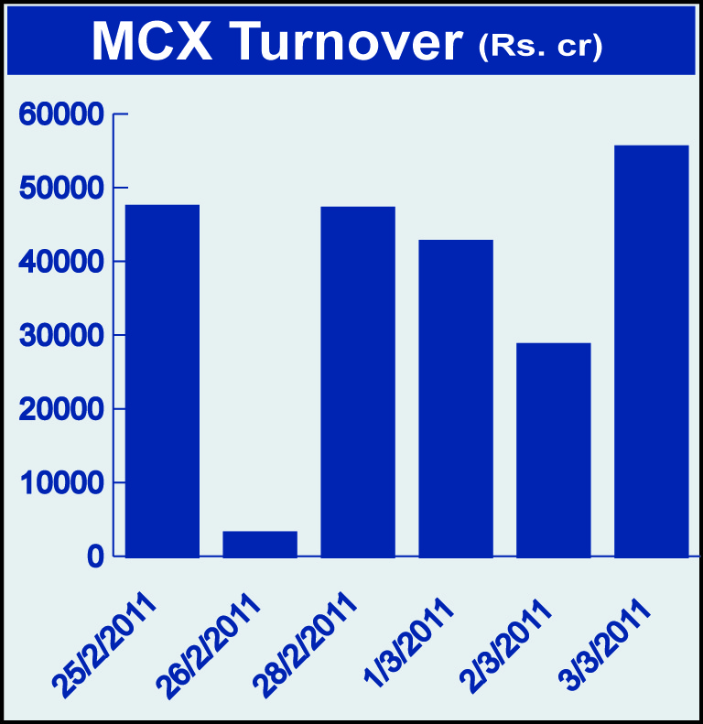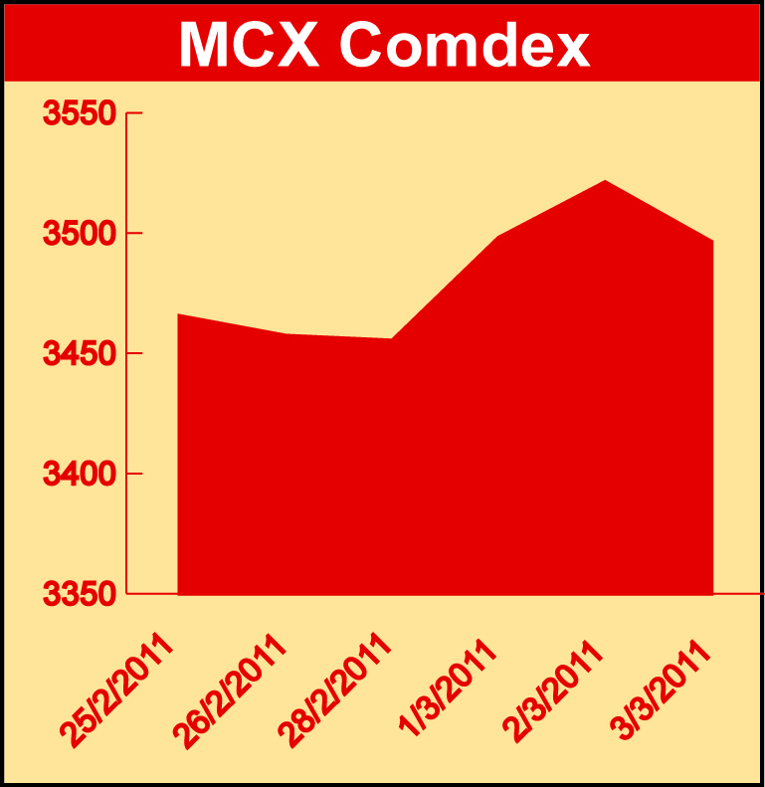

Bullion:
Gold April 11 contract was down by 1.13% to Rs 20858 per 10 grams, goldM April 11 contract was down by 1.13% to Rs 20865 per 10 grams and goldguinea March 11 contract was down by 0.84% to Rs 16664 per 8 grams. Silver May 11 contract was up by 1.10% to Rs 51359 per kg, silverM April 11 contract was up by 1.08% to Rs 51359 per kg and silverMIC April 11 contract was up by 1.08% to Rs 20358 per kg.

Metals
Aluminium March 11 contract was up by 1.21% to Rs 116.80 per kg, nickel April 11 contract was up by 2.13% to Rs 1304.80 per kg, lead March 11 contract was up by 3.14% to Rs 118.10 per kg, lead mini March 11 contract was up by 3.14% to Rs 118.10 per kg, copper April 11 contract was up by 1.77% to Rs 448.80 per kg while zinc March 11 contract was down by 0.09% to Rs 112.60 per kg, zinc mini March 11 contract was down by 0.13% to Rs 112.55 per kg and ironore April 11 contract was down by 4.42% to Rs 7155.00 per DMT.

Energy
BRCrude oil March 11 contract was up by 9.58% to Rs 5274.00 per BBL while crude oil May 11 contract was down by 0.55% to Rs 4678.00 per barrel and natural gas March 11 contract was down by 3.43% to Rs 172.00 per MMBTU.

AGRICULTURE:
Refsoyoil March 11 contract was up by 1.80% to Rs 632.30 per 10 kgs, CPO April 11 contract was up by 2.95% to Rs 548.10 per 10 kgs, cardamom May 11 contract was up by 1.18% to Rs 1152.70 per kg, kapas April 11 contract was up by 8.99% to Rs 1186.70 per 20 kgs, menthaoil March 11 contract was up by 0.66% to Rs 1144.10 per kg while potato April 11 contract was down by 7.18% to Rs 685.60 per 100 kgs, potatoTRWR May 11 contract was down by 8.87% to Rs 602.40 per 100 kgs and sugar May 11 contract was down by 3.03% to Rs 2940.00 per 100 kgs.

For further information please contact:

 | Alok Gupta  Sr. Manager, Corporate Communication, MCX  Phone No.: +91 22 61511600  Mobile No.: +91 9930267906  Email: alok.gupta@mcxindia.com

