Weekly Market Report (February 18, 2011 – February 24, 2011)

MCX – COMDEX

Open: 3320.34 High: 3521.95 Low: 3314.84 Close: 3485.38 Previous close: 3320.68

MCX Comdex was up by 4.96% to 3485.38, MCX Energy was up by 13.17% to 3202.77 and MCX Metal was up by 2.24% to 4427.95.

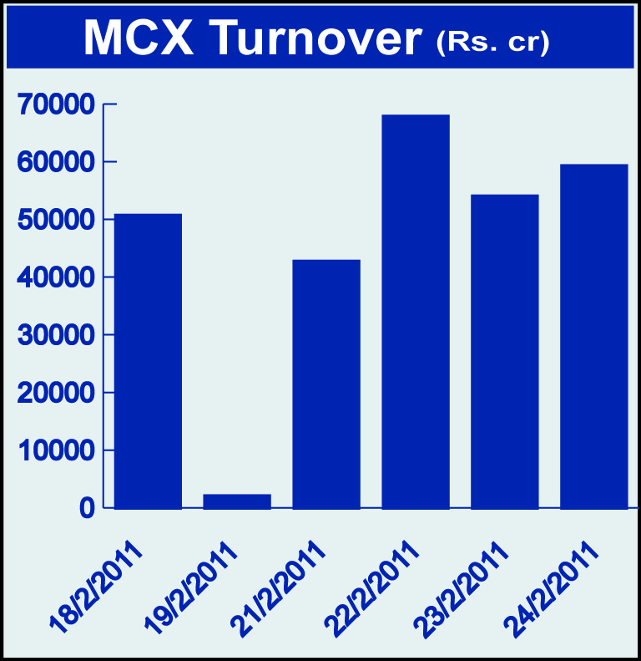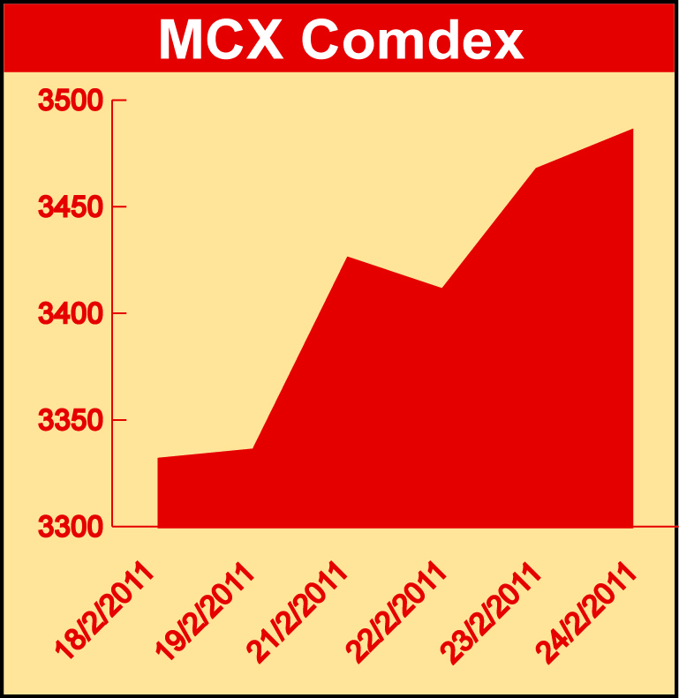

Bullion:
Gold April 11 contract was up by 2.83% to Rs 21096 per 10 grams, goldM April 11 contract was up by 2.80% to Rs 21103 per 10 grams and goldguinea April 11 contract was up by 2.77% to Rs 16956 per 8 grams. Silver March 11 contract was up by 6.05% to Rs 50034 per kg, silverM April 11 contract was up by 6.25% to Rs 50808 per kg and silverMIC April 11 contract was up by 8.39% to Rs 50811 per kg.

Metals
Aluminium April 11 contract was up by 1.39% to Rs 116.30 per kg while nickel February 11 contract was down by 2.61% to Rs 1264.50 per kg, ironore April 11 contract was down by 1.02% to Rs 7486.00 per DMT, lead February 11 contract was down by 3.55% to Rs 113.95 per kg, lead mini February 11 contract was down by 3.60% to Rs 113.90 per kg, zinc February 11 contract was down by 1.55% to Rs 111.45 per kg, zinc mini February 11 contract was down by 1.55% to Rs 111.45 per kg and copper February 11 contract was down by 2.72% to Rs 435.65 per kg.

Energy
Crude oil April 11 contract was up by 12.95% to Rs 4552.00 per barrel while natural gas April 11 contract was down by 0.76% to Rs 182.80 per MMBTU.

AGRICULTURE:
Potato March 11 contract was up by 4.58% to Rs 750.50 per 100 kgs, potatoTRWR March 11 contract was up by 11.18% to Rs 651.20 per 100 kgs, sugar March 11 contract was up by 1.40% to Rs 2969.00 per 100 kgs while kapas April 11 contract was down by 10.31% to Rs 1088.80 per 20 kgs, menthaoil April 11 contract was down by 4.37% to Rs 1061.90 per kg, refsoyoil March 11 contract was down by 4.27% to Rs 621.10 per 10 kgs, CPO April 11 contract was down by 6.97% to Rs 532.40 per 10 kgs and cardamom April 11 contract was down by 16.47% to Rs 1131.70 per kg.

For further information please contact:

 | Alok Gupta  Sr. Manager, Corporate Communication, MCX  Phone No.: +91 22 61511600  Mobile No.: +91 9930267906  Email: alok.gupta@mcxindia.com

